Safer Recruitment Policy

1 Introduction
1.1 This Safer Recruitment Policy has been produced in line with the DfE guidance ‘Keeping Children Safe in Education (Sept 22). This policy aims to ensure a safe and fair recruitment and selection is conducted at all times. Safeguarding and promoting the welfare of children and young people is an integral factor in recruitment and selection and is an essential part of creating safe environments for children and young people.

2 Recruitment and selection policy statement
2.1 Wychwood CE Primary School is committed to safeguarding and promoting the welfare of children and young people and expects all staff and volunteers to share in this commitment.
2.2 Wychwood CE Primary School is committed to attracting, selecting and retaining employees who will successfully and positively contribute to providing a valuable service. A motivated and committed workforce with appropriate knowledge, skills, experience and ability to do the job is critical to the school’s performance and fundamental to the delivery of a high quality service.

3 Purpose
3.1 To ensure the recruitment of all staff is conducted in a fair, effective and economic manner.
3.2 To achieve this purpose, those that are responsible for each stage of the recruitment process will demonstrate a professional approach by dealing honestly, efficiently and fairly with all internal and external applicants.

4 Scope
4.1 This policy applies to all the school employees and governors responsible for and involved in recruitment and selection of all staff.
4.2 The ultimate responsibility for recruitment and selection lies with the Governing Body. The Governing Body has delegated the responsibility to the Headteacher for appointing all staff.

5 Aims and Objectives
5.1 To ensure that the safeguarding and welfare of children and young people takes place at each stage of the process
5.2 To ensure a consistent and equitable approach to the appointment of all school staff.
5.3 To ensure all relevant equal opportunities legislation is adhered to and that appointees are not discriminated against on the grounds of race, nationality, gender, religion, age, disability, marital status, sexual orientation.
5.4 To ensure the most cost effective use is made of resources in the recruitment and selection process.

6 Principles
6.1 The following principles are encompassed in this policy:
- All applicants will receive fair treatment
- All applicant packs will include a job description detailing the post holders responsibilities for safeguarding.
- Employees will be recruited on the knowledge, experience and skills needed for the job
- Selection will be carried out by a panel with at least two members. At least one panel member will have received appropriate Safer Recruitment Training as recommended by the OSCB.
- Selection will be based on a minimum of completed application form, short listing and interview, but, whenever suitable, involve other assessments.
- Posts will normally be advertised on our school website and the advert will include reference to the school’s commitment to safeguarding and promoting welfare of children and young people.
- The Equality Act makes it a requirement to make reasonable adjustment to the recruitment process if an applicant makes the employer aware that they have a disability. This applies to the entire recruitment process, from advertisement to appointment.

7 Equal Opportunities
7.1 Wychwood CE Primary School is committed to providing equality of opportunity for all and ensuring that all stages of recruitment and selection are fair. Recruitment and selection procedures will be reviewed on a regular basis to ensure that applicants are not discriminated against on the grounds of race, nationality, gender, religion, age, disability, marital status, sexual orientation.

8 Safer Recruitment – Recruitment and Selection Training

8.1 It is a requirement that at least one member of the interview panel has completed OSCB approved Safer Recruitment Training prior to the start of the recruitment process. The following staff have received Safer Recruitment Training: Joseph Rubba and Rachel Stratford
The following Governors have completed Safer Recruitment Training: Iain Russell Jarvie and Danielle Wilden

9 Pre-recruitment Process

9.1 Objective

The objective of the recruitment process is to attract, select and retain staff who will successfully and positively contribute to the future development of the school. The first experience an individual has is important; therefore the experience should be positive and all those responsible for recruiting will:
- Leave a positive image with unsuccessful applicants
- Give successful applicants a clear understanding of the post and what is expected of them
- Take reasonable actions to reduce the risk of a bad selection decision recognising the potential cost and the school’s commitment to safeguarding children and young people.

9.2 Application Form
A standard application form will be used to obtain a common set of data from all applicants. The application form will be adapted for different posts but will always include key information on safeguarding. As such, candidates must provide information on employment history and if appropriate adequately explain the reasons for any gaps. The candidates must complete, sign and date the declaration and follow instructions regarding the appropriate disclosure of relevant criminal convictions.

9.3 Job Description and Person Specification
A job description and where applicable a person specification will be issued for all posts. In the case of volunteers this will include a volunteer role profile. The job description will have a clear reference to an individual’s responsibility to safeguard children and promote their welfare.

9.4 Criminal Self-Disclosure
All short-listed candidates will be asked to complete a self-disclosure form with their invitation to interview. Please see Appendix 2 for further guidance.

9.5 References
9.5.1 The purpose of seeking references is to obtain objective and factual information to support appointment decisions. They will always be requested directly from the referee using the standardised school form.
9.5.2 A minimum of two references will be sought on all short-listed candidates and will be obtained, where possible with your permission, before interview so that any issues or concerns they raise can be explored further with the referee, and/or taken up with the candidate at interview.
9.5.3 The school will take reasonable steps to verify references received electronically, this could include telephoning the referee.

9.6 Social Media Checks
As advised in KCSIE, social media checks will be conducted for shortlisted candidates and relevant incidents/issues that are publicly available on-line could be explored at interview with the candidate. Please see Appendix 3 for further guidance.

10 Interviews
The interview will assess the merits of each candidate for the post, including at least one question exploring their suitability to work with children and young people. The selection process for people who will work with children and young people will always include a face-to-face interview even if there is only one candidate.

10.1 Interview Panel
10.1.1 A minimum of two interviewers will form the interviewing panel.
10.1.2 The members of the panel will:
- have the necessary authority to make decisions about appointments;
- be appropriately trained, (at least one member of interview panel will have undertaken Safer Recruitment Training).
- meet before the interviews to:
  - reach a consensus about the required standard for the job to which they are appointing;
  - consider the issues to be explored with each candidate and who on the panel will ask about each of those.
10.1.3 Where a candidate is known personally to a member of the selection panel this will be declared before shortlisting takes place. It may then be necessary to consider changing the selection panel to ensure that there is no conflict of interest.
10.2 Scope of the Interview
In addition to assessing and evaluating the applicant’s suitability for the particular post, the interview panel will also explore:
- the candidate’s attitude toward children and young people;
- his/her ability to support the school’s ethos for safeguarding and promoting the welfare of children;
- any gaps in the candidate’s employment history;
- any concerns or discrepancies arising from the information provided by the candidate and/or a referee.

11 Conditional Offer of Appointment: Pre Appointment Checks
11.1. An offer of appointment to the successful candidate will be conditional upon:
- verification of the candidate’s identity
- verification of eligibility to work in the UK
- appropriate overseas check, and references from any overseas education employer after this date.
- verification of the candidate’s mental and physical fitness to carry out their role
- the receipt of at least two satisfactory and verified references
- verification of qualifications
- verification of professional status where required e.g. QTS status (unless properly exempted)
- a check of the DfE Barred List
- a satisfactory DBS Enhanced Disclosure, with the certificate seen and verified by the school. (for Volunteers a written risk assessment in relation to the undertaking of an Enhanced DBS Disclosure)
- a check using the Employer Access Online Service to see if a prohibition order issued by the Secretary of State for Education or GTCE sanction exists against the individual (for posts carrying out ‘teaching work’)
- verification of successful completion of statutory induction period (applies to those who obtained QTS after 7 May 1999) unless the successful candidate is an NQT undertaking their statutory induction (for teaching posts).
- Any additional checks as deemed appropriate
11.2 All checks will be appropriately documented and retained on the individuals personnel file with information recorded on the school’s central record in line with the statutory requirements set out in Keeping Children Safe in Education (Sept 2022). Where information is unsatisfactory or there are discrepancies in the information provided this will be followed up.
Where:
- the candidate is found to be on the relevant barred List, or the DBS Disclosure shows s/he has been disqualified from working with children by a Court; or,
- an applicant has provided false information in, or in support of, his/her application; or,
- there are serious concerns about an applicant’s suitability to work with children, the facts will be reported to the Local Authority Designated Officer (LADO).
11.3 If an individual’s DBS certificate is not completed a member of staff would only be able to commence work if the school is satisfied that:
- appropriate supervision is in place
- other checks (references etc) have are completed satisfactorily
- the DBS barred list check has been completed
11.4 The following personnel should have their details entered on the School Central Register
- Staff in regulated activity
- Regular and/or unsupervised Volunteers, including Governors
- Supply Staff
- Regular visiting professionals in regular contact with children – e.g. Coaches
- Contract staff in regular contact with children
All leavers will be deleted off the school central register immediately

12. Post Appointment Induction
There will be an induction programme for all staff which includes the arrangements for Child Protection and Safeguarding, Keeping Children Safe in Education (Part 1 (or Annex A as appropriate) and Annexe B) and Safer Working Practice Guidance.

13. Supply/Agency Staff
When the school needs to use the services of a supply agency we will ensure the agency operates a safer recruitment process and provides confirmation that the following have been checked and judged as satisfactory:
- Identity
- Enhanced DBS Disclosure
- Right to work in the UK
- The DBS Barred List
- Any Prohibition Order, Interim Prohibition Order or GTCE sanction for those undertaking ‘ teaching work’
- Qualifications (where applicable)
- Overseas Checks, including and EEA check where applicable (see Appendix 1)
When the supply member of staff arrives at the school, their identity will be checked and it will be confirmed that they are the same person on the documentation from the agency. The supply staff’s details will be entered on the Single Central Record (SCR).

A copy of the Safer Recruitment Checklist (Appendix 1) will be completed with supporting evidence and placed in the file of successful candidates.
Appendix 1 - Safer Recruitment Checklist
Post ___________________

Date___________________

Recruitment and selection checklist | Initials | Date
Pre-interview:
Planning - Timetable decided: job specification and description and other documents to be provided to applicants, reviewed and updated as necessary. Application form seeks all relevant information and includes relevant statements about references etc
Vacancy advertised (where appropriate) Advertisement includes reference to safeguarding policy, that is, statement of commitment to safeguarding and promoting welfare of children and need for successful applicant to be DBS checked
Applications on receipt - Scrutinised – any
discrepancies/anomalies/gaps in employment noted to explore if candidate considered for short-listing
Short-list prepared
References – seeking
Sought directly from referee on short-listed candidates; ask recommended specific questions; include statement about liability for accuracy
References – on receipt
Checked against information on application; scrutinised; any discrepancy/issue of concern noted to take up with referee
and/or applicant (at interview if possible)
(If received by email – accompanying email to verify authenticity. If not from professional email address, follow up to ensure authenticity)
Invitation to interview - Includes all relevant information and instructions and the self-disclosure form.
Interview arrangements - At least two interviewers; panel members have authority to appoint; have met and agreed issues and questions/assessment criteria/standards
Interview - Explores applicants’ suitability for work with children as well as for the post
Self-Disclosure – Completed self-disclosure is submitted and seen by the member of the panel who is safer recruitment trained.
Note: identity and qualifications of successful applicant verified on day of interview by scrutiny of appropriate original documents; copies of documents taken and placed on file;

where appropriate applicant completed application for DBS disclosure
Conditional offer of appointment: pre appointment checks. Offer of appointment is made conditional on satisfactory completion of the following pre- appointment checks and, for non-teaching posts, a probationary period
References before confirmation of appointment: (if not obtained and scrutinised previously)
(If received by email – accompanying email to verify authenticity. If not from professional email address, follow up to ensure authenticity)
Identity (if that could not be verified at interview)
Qualifications (if not verified on the day of interview)
Permission to work in UK, if required
School record sight of DBS certificate - where appropriate satisfactory DBS certificate.

DBS Barred list check – applicant is not barred from working with Children (this must be completed before the applicant commences work)
Childcare (Disqualification) Regulations 2009 Letter – for any staff who work in childcare provision or who are directly concerned with the management of such provision as defined in the statutory guidance.
Health – the candidate is medically fit Medical Pre Employment Questionnaire
Prohibition from Teaching Work Check – For those carrying out teaching work (see below) the teacher has not been included in the prohibition list or interim prohibition list or has a GTCE sanction.
Qualified Teacher Status (QTS) Check – (for teaching posts in maintained schools) the teacher has obtained QTS or is exempt from the requirement to hold QTS (for teaching posts in FE colleges) the teacher has obtained a Post Graduate Certificate of Education (PGCE) or Certificate of Education
(Cert. Ed) awarded by a higher education institution, or the FE
Teaching Certificate conferred by an awarding body
Overseas Checks – for individuals who have lived or worked abroad in the last 10 years.**(See Below)
(For those carrying out teaching work within the EEA area this will include an EEA prohibition order check through Employer Access until Jan 21, after this date it will include a
reference from any education employer overseas in the same period)
Statutory Induction Completed (for teachers who obtained QTS after 7 May 1999 and are not employed as NQTs)
Risk Assessment – for Volunteers a written Risk assessment in relation to undertaking an Enhanced DBS
Child Protection & Online safety training and other induction such as H&S, Safe Working Practice / code of staff behaviour, etc
Including:
Safeguarding & Child Protection Policy
Safer Working Practice Guidance
Whistleblowing procedures
KCSiE & Annexe A
ICT Acceptable Use Policy
Online Safety Policy & Guidance
Children Missing Education Policy Behaviour Policy

Each of the following activities is teaching work: planning and preparing lessons and courses for pupils, delivering* lessons to pupils; assessing the development, progress and attainment of pupils; and reporting on the development, progress and attainment of pupils.
- “delivering” includes delivering lessons through distance learning or computer aided techniques. The activities specified above are not teaching work for the purposes of the Regulations if the person carrying out the activity does so (other than for the purposes of induction) subject to the direction and supervision of a qualified teacher(2) or other person nominated by the head teacher to provide such direction and supervision.

- “delivering” includes delivering lessons through distance learning or computer aided techniques. The activities specified above are not teaching work for the purposes of the Regulations if the person carrying out the activity does so (other than for the purposes of induction) subject to the direction and supervision of a qualified teacher(2) or other person nominated by the head teacher to provide such direction and supervision.

** The DfE does not issue guidance on which circumstances require these overseas checks, stating that it is for schools to determine. However, with effect from 6th April 2017 the Home Office confirmed that an overseas criminal check will be completed for everyone in an education role applying for a visa to work in the UK.
The requirement is mandatory to applicants from overseas applying under certain Standard Occupational Classification (SOC) codes, including teaching and school leadership. The requirement to provide an overseas criminal record certificate applies to anyone that has lived abroad for 12 months or more in the last 10 years. From April 2017 schools have a statutory duty to inform Tier 2 skilled worker applicants of the need to source and submit overseas criminal certificates as part of their visa application. You can find an FAQ document about obtaining overseas criminality information here: Obtaining Overseas Criminal Record Checks

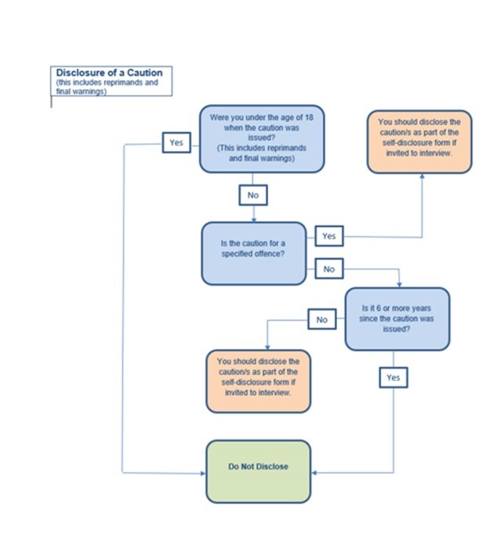

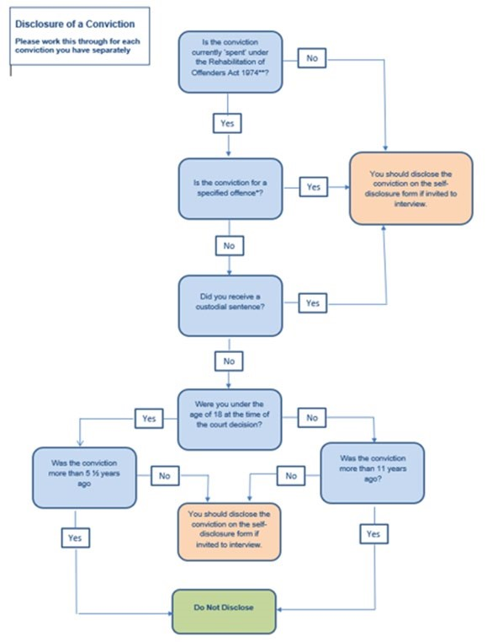

Appendix 3 - KCSIE – Online Recruitment Checks – LGA Response



KCSIE – online recruitment checks

The Keeping Children safe in Education statutory guidance is regularly updated, with a reference to conducting online searches of applicants contained in the latest iteration, due to come into force from September 2022.

On page 51, when detailing the process around shortlisted candidates, the new guidance says:

220. In addition, as part of the shortlisting process schools and colleges should consider carrying out an online search as part of their due diligence on the shortlisted candidates. This may help identify any incidents or issues that have happened, and are publicly available online, which the school or college might want to explore with the applicant at interview.

We’ve had a number of colleagues contact us for guidance on that new paragraph.

First of all, it’s helpful to understand the incident that prompted the DfE to look to include that “should” within the updated KCSIE guidance.

We understand that some years ago there was a teaching assistant from abroad that was employed by a school in the UK. The school had completed the necessary criminal records checks. However, the law in the specific country stated that if a person under the age of 18 commits an offence, the offence is removed from their criminal record after 10 years. This individual had committed a very serious offence involving a small child, but because they were under 18 and applied for the job in the UK after 10 years their criminal record was clear, and the school was not made aware of this issue. While the school did not do anything wrong, an internet search would have revealed this information.

Consultation revealed varying practice and views, but it was clear that some schools were informally doing this sort of online search, this update to the KCIE guidance is about formalising those searches and turns it into a “should” in relation to shortlisted candidates in relation to safeguarding suitability.

There isn’t currently more detailed guidance, with the DfE suggesting schools should decide for themselves whether they have sufficient information to judge suitability.

Existing HR advice from Local Authorities and Academy Trust specialists should apply. Bearing in mind this is part of a safeguarding check, the search is purely about whether the individual is suitable to work with children. Care must be taken to avoid unconscious bias and any risk of discrimination. In line with that approach, it may be sensible to have someone not on the appointment panel to conduct the search – only sharing info that is relevant and of concern.

We are aware that some organisations are already offering to support schools by conducting these searches at cost, and that some legal and safeguarding experts have shared their interpretation of the DfE guidance which we believe goes further than the DfE policy intention – which is more simply an online search to check suitability of working with children.

As part of an Ofsted inspection, a school’s single central record will be checked to ensure pre-appointment checks have been carried out. Part of the due diligence checks will be an internet search, however, we are aware schools are concerned that the guidance is not prescriptive on how far to go back and are worried this will be identified as a failure by Ofsted. We put this question to the DfE and understand Ofsted have said their inspectors would not normally go into that level of detail when looking at due diligence checks. We have been advised that the Ofsted handbook will be updated shortly.

If this develops or we get any further information or guidance we will share via the usual channels.

