Key Areas of Learning

**Where could I go if I travelled the world?**

**

e.

As Geographers, this term we will be engaged with map work to learn about the continents and oceans of the world. We will develop our map reading skills and create a simple map and key for our Forest School site. We will also look at different areas of the world focusing on human and physical features.

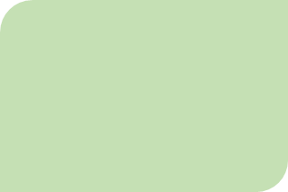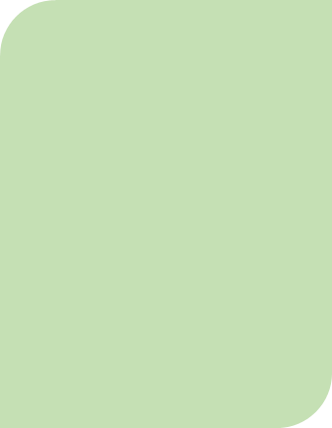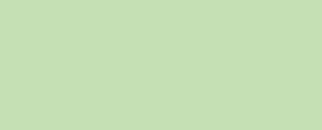P.

For Relationship Education the children will be using the zones of regulation displays in their classrooms to encourage them to think about the emotions that they are feeling. As part of this, we will be thinking about strategies that the children can use to manage their emotions.

At Forest School we will be continuing to observe the changes that happen during Autumn. We will also be building on some of the skills that the children have been developing during Term 1, such as teamwork and resilience. We will also be taking part in Anti Bullying Week and Children in Need.

We will be exploring ‘working scientifically’ this term, learning about and practicing the skills of observation, finding patterns, predicting, investigating and measuring, being accurate and working together.

**SCIENCE**

Indoor PE this term will continue to develop shapes with our bodies in movement and balance. Outdoor PE this term is Netball, and we will be focusing on our catching skills.

In Art, the children are going to explore colour mixing, shades and tones. In DT, they will look at how to make simple moving parts using paper and card. They will apply their skills to create Christmas cards.

We will be thinking about why Christians celebrate Christmas. We will also be finding out about the Jewish celebration of Sukkot and how it is similar to our Harvest festival.

**R.E.**

**ART / DT**

We will all be taking part in whole class reading sessions, using the ‘reading dogs’ to discuss and develop the different skills of reading.

Children will be phonic assessed and regrouped appropriately. Year 2 will continue the RWI spelling programme.

**READING AND PHONICS**

**P.E.**

This term our main focus will be on addition and subtraction, considering different methods for each operation. As well as developing our fluency, we will be looking at solving problems. We will be continuing to practise our skip counting at the beginning of each maths lesson.

This term we are focusing our writing on the story ‘Grandad’s Island’.

The children will be learning a simplified version of the story and then creating their own journey stories. As we move closer to Christmas, we will be preparing a retelling of a Christmas story to perform.

**MATHEMATICS**

**ENGLISH**

**Spiritual, Moral and Cultural Awareness and Relationship Education**

**MATHEMATICS**

**PSHE**