Questions?  If you have any further questions about anything raised in this booklet, please feel free to contact any member of the EYFS and KS1 team.  Contact Us  Milton Road, Shipton-under-Wychwood,  Chipping Norton, Oxon OX7 6BD  Phone: 01993 830059  Email: office.3257@wychwood-pri.oxon.sch.uk  Web: wychwood-pri.oxon.sch.uk  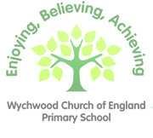 Wychwood CE Primary School Milton Road, Shipton-under-Wychwood, Chipping Norton, Oxon OX7 6BD |  |  | How we teach Reading  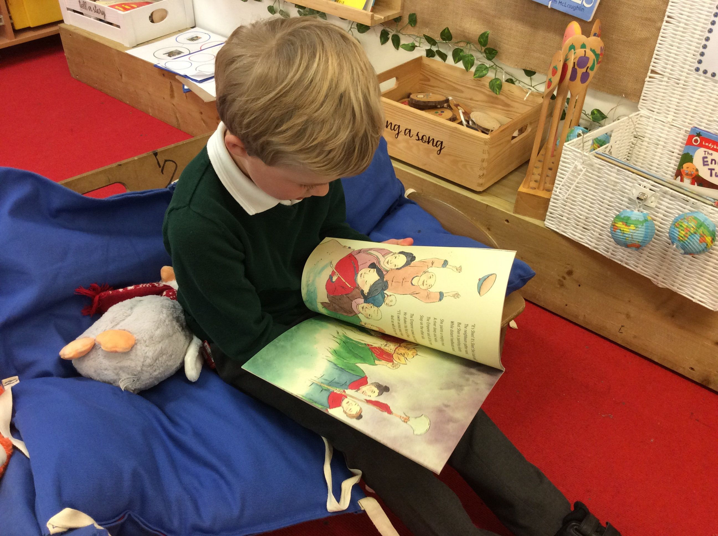  - Wychwood CE Primary School

Table of Contents  This booklet aims to explain how we teach reading in the first three years of your child’s education in our school. We hope you find it useful.  Phonics 1  Read, Write, Inc. 1  Reading 2  Children following phonics programme 2  After phonics 2  One to one reading………………………………………………….3  Whole class texts……………………………………………………...3  Book bands 4  Reading at home……………………………………………………….5 |  |  | Reading at home  Recording reading  Children learn to read by practising. Little and often is the key and we would encourage you to hear your child read for ten minutes a day where possible. You can record your child’s reading progress on seesaw. Just the date, title and pages read is fine but if you would like to add any comments please feel free. There is no need to record every day, one message per week will be fine. We will check seesaw every Friday and children who have recorded having read five times or more each week will receive a house point and a raffle ticket to reward their (and your!) efforts. When raffle tickets are drawn, the winner will receive a book token.  Reading to your child  Another way to support your children as they learn to read is to read to them. As well as their banded reading book, children will be able to take home another book from our collections in the reading corner or library. This book is for you to share with your child. Children often like to hear the same book read to them many times and this is a great opportunity to discuss the pictures and characters in a story or to talk about interesting facts you have read together. This kind of ‘book talk’ is extremely helpful in developing children’s comprehension skills. Your teacher will provide you with a booklet that includes some questions to help you frame these conversations.  To print this booklet two-sided, click File and then click Print. Under the option that defaults to Print One Sided, select a two-sided print setting. This booklet is setup to flip on the short side of the page.
 |  |  | 5

Book Bands  We have recently adopted the Read Write Inc. system of colour banded books in EYFS and KS1. Our books have been organised into coloured bands according to their level of difficulty and children will have the opportunity to select their own books to take home to read with you or another adult.  This system provides children with a broad selection of books to choose from and allows children to move through the coloured bands at their own pace rather than following a reading scheme from start to finish.  The band we have chosen for each child is based on their phonic knowledge and corresponds directly to the phonics group they are in. This means that they should be able to decode all of the words within each book. You may notice that some of the books your child comes home with are ones he or she has already encountered. Please don’t worry about this or think it means your child has fallen behind. We believe they are likely to make quicker progress if they are reading books at the right level for them. You may also find that your child just enjoys a particular book and so chooses to read it more than once. This is perfectly natural and provides a great opportunity to build speed and fluency when reading. |  |  | Phonics  What is phonics?  Phonics is the explicit teaching of each sound in English and the corresponding letter or group of letters that can make that sound. For example, the sound ‘or’ as in fork can also be made with ‘aw’ as in crawl, etc. A good grounding in phonics enables children to decode unfamiliar words by sounding them out and then blending the sounds into words. Eventually, they will be able to recognise most words on sight without the need to sound them out.  Read, Write, Inc.  We follow a programme called Read, Write, Inc., a widely used and respected way of teaching phonics that helps children to become accurate and fluent readers. Read, Write, Inc. uses pictures and phrases to help the children to remember each sound. Your child’s teacher will provide you with a sheet with these sounds on so that you can support your child as they progress through the programme. Children also learn to read words that do not follow the usual patterns that they have learned. These words are called ‘red’ or ‘tricky’ words and children are taught to read these words as they encounter them in texts throughout the programme.
4 |  |  | 1

Reading  Learning to read is not simply about being able to decode words on a page. Children also need to be able to understand what they have read. We call this skill reading comprehension. We will continue to teach this to the children throughout their time at school with us.  “The more that you read, the more things you will know. The more that you learn, the more places you'll go.” Dr. Seuss, I Can Read With My Eyes Shut!  Children following the phonics programme  While the children are still following the Read, Write, Inc. programme, they will also be reading a range of texts which are at an appropriate level for them. These texts will be read during the daily phonics sessions with lessons focussed on increasing accuracy, fluency and comprehension.  Children who have completed the phonics programme  After children have completed the phonics programme, they will have a daily reading session. During these lessons, children will read and discuss a wide variety of texts. They will learn specific skills such as skimming and scanning, making predictions and inferring meaning from a text. |  |  | One to One reading  In addition to the reading sessions described above, some children will continue to read with an adult one-to-one every week. We will send a message on Seesaw when this happens. If your child is not reading one-to-one with a teacher each week, please be reassured that they are being heard within the phonics and reading groups that take place daily. The progress of every child will be closely monitored and if we believe a child would benefit from extra support with their reading we will provide this in the form of one-to-one or small group interventions.  Whole class texts  Teachers will also be reading to your children from high-quality texts throughout each week, exposing children to books that would be beyond their ability to access independently. These sessions are a wonderful way to introduce new vocabulary and to model comprehension skills. They also aim to foster a love of reading which is perhaps the most important thing of all.  Early Years Foundation Stage and Key Stage 1  Phonics teaching, including comprehension skills Reading comprehension teaching  Whole class texts – read by teachers with associated ‘book talk’ during English lessons  Topic based texts shared throughout every term with the whole class  Weekly visits to the library to choose and share books  Regular opportunities to read for pleasure in the classroom
2 |  |  | 3

